Decision Making Guide

Choose one strategy, approach, or small scope of work within your larger change effort. Answer the following questions as a team. Using a positive frame, a great option is to choose something that is getting positive results you want to amplify. Or, start something new from the principles/foundation of the effort that is already working well.

What are the big decisions associated with the selected strategy, approach or small scope of work for the next 12 months?
For example:
- Should this effort continue to be structured as is or does it need a makeover?
- Do we want to scale this effort, and if yes, with who and where?
- How can we refocus this effort in such a way that equity is centered?

Big Decision 1
Big Decision 2
Big Decision 3

What are all the smaller decisions embedded in each of the big ones for the next 12 months?
For example:
- #1
- How should leadership be structured for this effort?
- What perspective will be needed to consider structure options?
- What’s the best way to facilitate a process to consider structure options?

Big Decision 1: _________________ | - __________________________________  - __________________________________  - __________________________________  - __________________________________
Big Decision 2: _________________ | - __________________________________  - __________________________________  - __________________________________  - __________________________________
Big Decision 3: ________________ | - __________________________________  - __________________________________  - __________________________________  - __________________________________

Choose the Big Decision that feels most important and apply to remainder of the questions below.

Acknowledge that you are making a decision and name it.

What is the end goal of this decision?

What do you hope to have in place at the end of the decision-making process?

Decide about the deciding early on. What process would be best for making this decision?
- Consensus
- Small group
- Advisory Group
- Leader
- Other
Being transparent and open about how a decision will be made will potentially affect how the decision is accepted by others. Consensus is not the only way. Just be clear at the beginning of the decision-making process how decisions will be made (and with what feedback).

Put a timeframe around when the decision should be made. This helps keep us out of analysis paralysis.

Brainstorm options without constraints/limiting beliefs. We often limit our own options because of limitations that can in fact be changed. Try to open up your thinking and consider ALL the options that could be available for this decision. Note: this should be rapid fire brainstorming. Try to stay in the idea generation space and not apply feasibility constraints. This part is especially important if you are feeling indecisive…. Because you may not have the right options yet!
 |  | What value does it ultimately offer? | Who does it ultimately benefit?
Option 1

Option 2

Option 3

Option 4

Option 5

Option 6

Option 7

Option 8

Option 9

Option 10

Now rank the options 1 being the lowest, 10 being the highest for impact. Rank them again for feasibility. Note: Try to consider that part of a scope of work could focus on altering feasibility constraints, so don’t limit your rank based on current feasibility but instead consider with some supports to make some changes to current constraints what would the feasibility score be.
 | Impact | Feasibility
Option 1

Option 2

Option 3

Option 4

Option 5

Option 6

Option 7

Option 8

Option 9

Option 10

Plot the coordinates on the graph below:
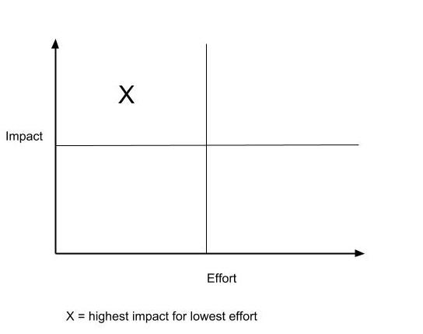

Notice what falls into the high impact, low effort quadrant. Also notice what falls into the high impact, high effort quadrant.

For the analysis questions below, choose a single option that plotted in the high impact/low effort quadrant.
Option #______
What are the advantages and tradeoffs? | Advantages  Tradeoffs
If you shift one thing what are the intentional and unintentional effects of that shift.

What possible opportunities could emerge for each option. | - ___________________________________________  - ___________________________________________  - ___________________________________________
What other perspectives do you need to inform choosing this option?

Which options pair well with this one? Is there a way you can do more than one, or two?

Repeat this process for all viable options. Consider questions like- six months later…. what could change our minds?

Then, choose one or a few to prototype and test with lots of opportunities for feedback and iteration.

Loop back to the actual decision and confidently choose. Take first steps into the decision to make it real.
Step 1.

Step 2.

Step 3.

Reflect on how might this decision affect other ones?

What would the mini-mileposts points be as we go along where we can revisit decisions, learn from what is working and what isn’t, and shift/pivot as necessary?
1.

2.

3.

4.

5.

At what points of the decision-making process and implementation can we celebrate and recognize the efforts that have gone into this scope of work. What will you celebrate? (ie: transparency, gathering diverse perspectives, how equity was centered in the process, how team/org values were used as criteria, how decisions were communicated, how learning and reflection opportunities were utilized, etc.)

