**How to Join a Zoom Meeting**

Zoom is a video conferencing software. It allows meeting participants to see and hear each other, and it allows the meeting organizer to share their screen (to present PowerPoint slides or show other visuals).

You have multiple options for how to join the meeting:

We recommend that you join the meeting from **a computer that has a webcam** (many laptops have them built in) or a **tablet**. Joining from a computer or a tablet with a good size screen will allow you to see the presentation and see the other participants in the meeting. If your computer doesn’t have a webcam, that’s fine. You will still be able to participate in the meeting through the audio, and you’ll be able to see the presentation and the other participants.

You can also join from a **smartphone**, which will allow you to see and hear everything, but the screen may be too small to see details on the presentation slides.

You can also dial into the meeting using any **phone**. Joining via phone is just like joining a conference call. You will not be able to see the presentation slides, but you will be able to speak and hear everything.

Contents

Join Using a Computer 2

Join Using a Smartphone or Tablet 8

Join Using a Phone 15

## Join Using a Computer

This is the recommended way to join the meeting. You will be able to see and hear everything that happens in the meeting. If your computer has a webcam, other participants will be able to see you.

There are two options for joining via computer. You can download the Zoom software, or you can join without downloading anything. We recommend downloading the software since it isn’t a large program, and you will be able to use all the features that way. If you aren’t able to install software, you can join without downloading anything.

**Download the Zoom Software and Join Via Computer (preferred option)**

There are detailed instructions below for how to join a meeting with the Zoom software. You can also watch this 1-minute video by Zoom for an overview: <https://www.youtube.com/watch?v=hIkCmbvAHQQ&feature=emb_logo>

First, download the “Zoom Client for Meetings” at this link: <https://zoom.us/download>. Follow the steps to install the software.

When the software opens, click the button that says “Join a Meeting”:

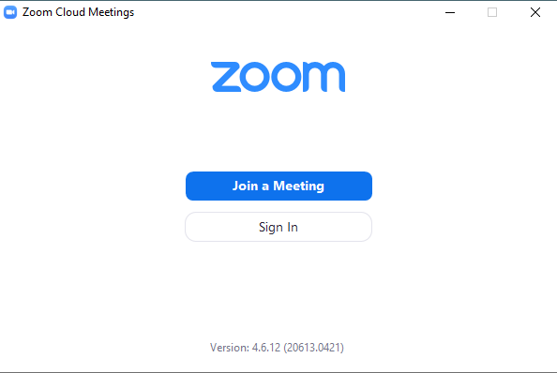

*Continued on the next page.*

You will be prompted for the meeting ID and your name:

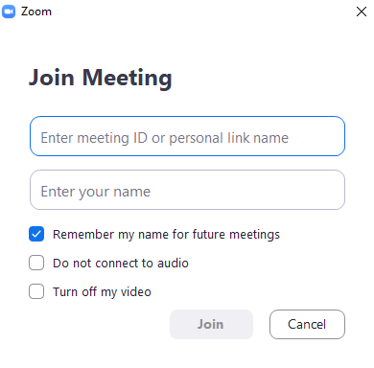

The meeting ID can be found on the invitation (this is only an example):

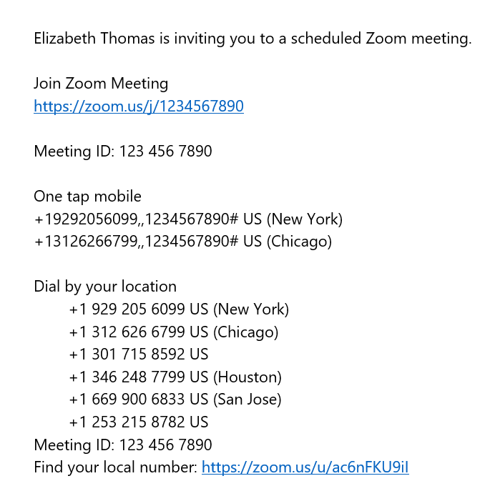

*Continued on the next page.*

You will see two options for what kind of audio connection you want to use. Click “Join with Computer Audio” if you want to use your computer’s microphone and speakers. If you want to view the meeting on your computer screen but dial in with a phone for the audio, click “Phone Call.” If you select the phone option for audio, Zoom will give you instructions for how to dial in.

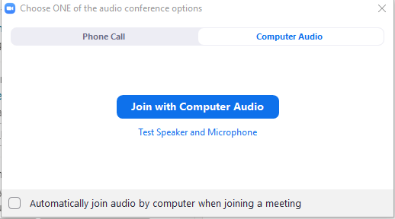

Inside the meeting, you will see a control bar at the bottom of your screen:



You can use this control bar to do a few different things:

1. Click the Mute/Unmute icon (far left) to mute or unmute yourself. If there are several people on the meeting, there can be lots of combined background noise, so best practice is to stay on mute unless you are speaking and then unmute yourself when you want to speak. (If you joined via phone audio, press *6 to mute or unmute yourself.)
2. Click the Start/Stop Video icon (second from left) to start or stop video of you (if you have a webcam).
3. Click the chat icon (middle of the bar) to open up the chat box. This will send a message to everyone in the meeting. If you want to send a message to only one person, click the blue button that says “everyone” and select an individual person instead:



**Join Via Computer Without Downloading Anything**

To join with this option, the recommended web browser is Google Chrome. Other browsers may work, but use Chrome if you have it.

To join without downloading the software, you will need to have a Zoom account. If you do not have one, you can create one for free. Go to [zoom.us/freesignup](https://zoom.us/freesignup). Enter your email address and click “Sign Up.”



Follow the steps from there to create an account:

1. You will be prompted to enter your date of birth and then click “Continue.”
2. Zoom will send an email to the address you entered. Open up the email and click the confirmation link.
3. Clicking the confirmation link in the email Zoom sends you will take you to a page where you can enter your name and create a password. Once you create a password, you will be logged in, and you can open the meeting.

*Continued on next page.*

To open the meeting, click the link in the meeting invitation (this is only an example):



When you click the link, you will see the screen below. Click “join from your browser.”

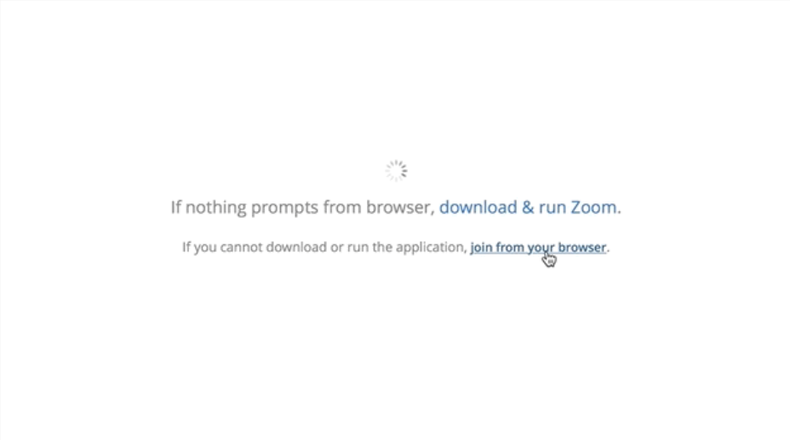

Once you join the meeting, you will see two options in the middle of the screen for what kind of audio connection you want to use. Click “Join Audio by Computer” (the blue box) if you want to use your computer’s microphone and speakers. If you want to view the meeting on your computer screen but dial in with a phone for the audio, click “Phone Call.” If you select phone call for the audio, Zoom will give you instructions for how to dial in.

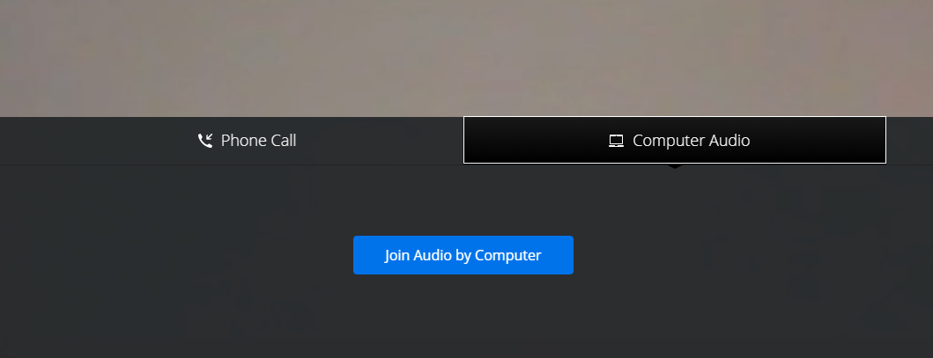

Inside the meeting, you will see a control bar at the bottom of your screen:



You can use this control bar to do a few different things:

1. Click the Mute/Unmute icon (far left) to mute or unmute yourself. If there are several people on the meeting, there can be lots of combined background noise, so best practice is to stay on mute unless you are speaking and then unmute yourself when you want to speak. (If you joined via phone audio, click *6 to mute or unmute yourself.)
2. Click the Start/Stop Video icon (second from left) to start or stop video of you (if you have a webcam).
3. Click the chat icon (middle of the screen but on the right in the image above) to open up the chat box. This will send a message to everyone in the meeting. If you want to send a message to only one person, click the blue button that says “everyone” and select an individual person instead:



## Join Using a Smartphone or Tablet

To join from a smartphone or a tablet, follow the instructions below depending on your type of device (Apple or Android). If you have a tablet, you will be able to see more or see more details on the larger screen, but you can also join from a smartphone.

**Android**

Visit the Google Play Store to install the Zoom app.

Open the app, and click “Join a meeting” at the bottom of the screen. (No need to sign in.)

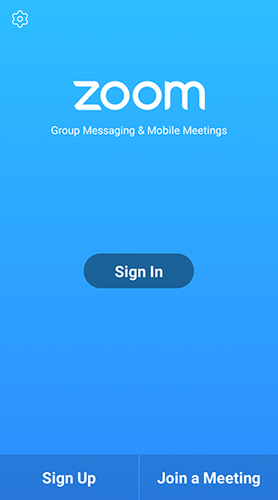

*Continued on next page.*

On the next screen, enter the Meeting ID, which can be found in the invitation. You can also enter your name. (“Molly Parker” is the example below.) Then click “Join Meeting.”

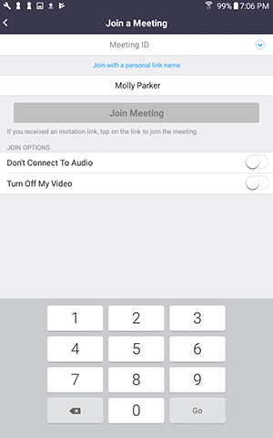

*Continued on the next page.*

Once you are in the meeting, if you are on a phone, you will have two options for how to join the audio for the call. We suggest clicking “Call via Device Audio,” which will use your microphone and speaker but will not actually make a call from your phone.

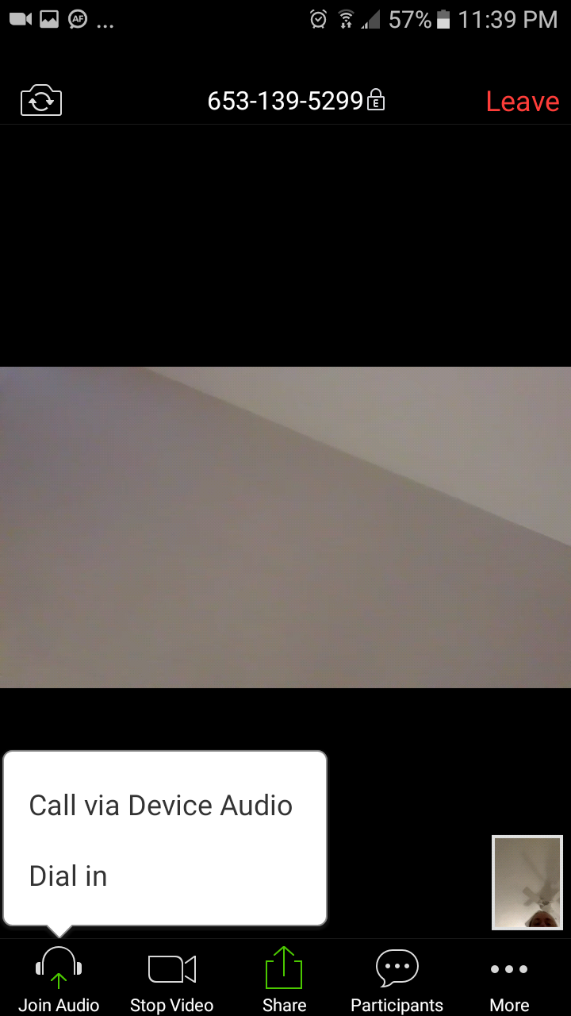

123-456-7890

You will have a few controls at the bottom of the screen:

1. Use the Mute/Unmute icon (far left) to mute or unmute yourself. If there are several people on the meeting, there can be lots of combined background noise, so best practice is to stay on mute and unmute yourself to speak.
2. Click the Start/Stop Video icon (second from left) to start or stop video of you.
3. Click the three dots on the right (“More”) to access the chat box. You can enter a chat message that will be sent to everyone in the meeting. If you want to send a message to only one person, click the blue button that says “everyone” and select an individual person instead:



**Apple (iOS)**

Visit the App Store to install the Zoom app.

Open the app, and click “Join a Meeting.” (No need to sign in.)

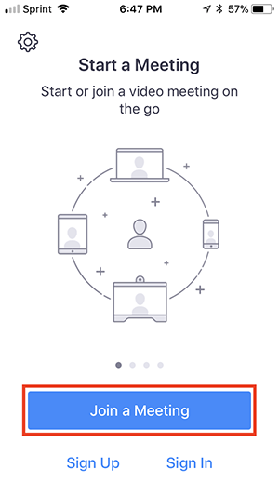

*Continued on next page.*

On the next screen, enter the Meeting ID, which can be found in the invitation. You can also enter your name. (“Molly Parker” is the example below.) Then click “Join.”

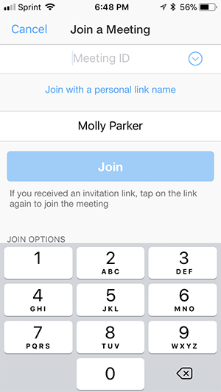

*Continued on the next page.*

Once you are in the meeting, if you are on an iPhone, you may have two options for how to join the audio for the call. We suggest clicking “Call via Device Audio,” which will use your microphone and speaker but will not actually make a call from your phone.

You will have a few controls at the bottom of the screen:

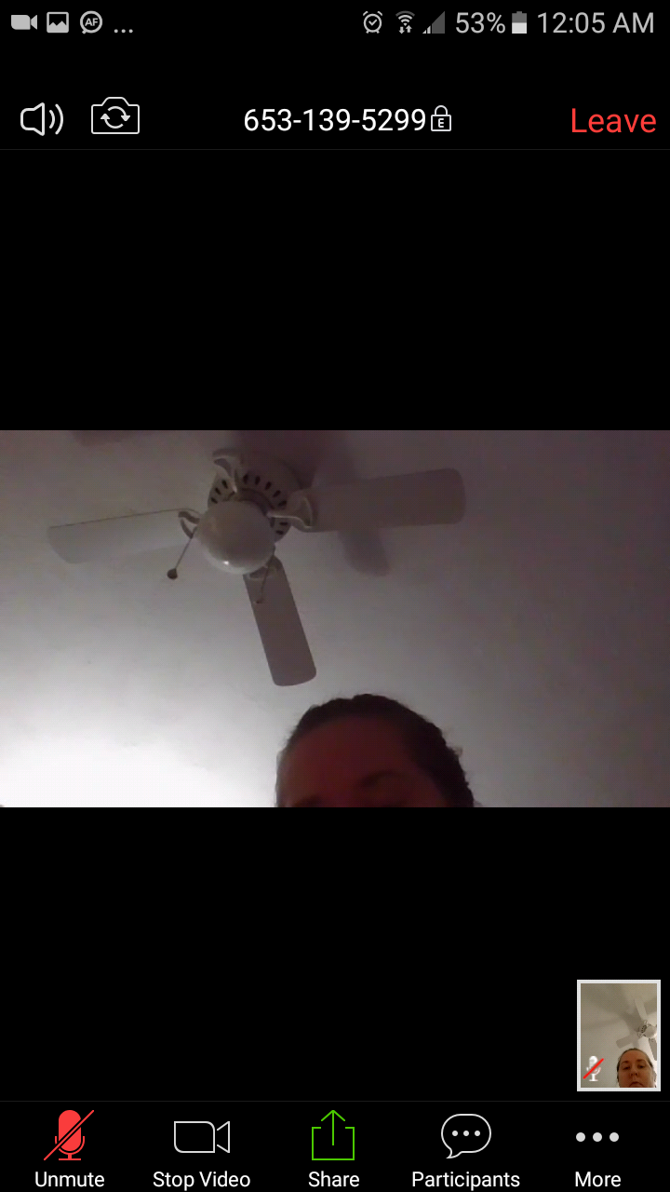

1. Use the Mute/Unmute icon (far left) to mute or unmute yourself. If there are several people on the meeting, there can be lots of combined background noise, so best practice is to stay on mute and unmute yourself to speak.
2. Click the Start/Stop Video icon (second from left) to start or stop video of you.
3. Click the three dots on the right (“More”) to access the chat box. You can enter a chat message that will be sent to everyone in the meeting. If you want to send a message to only one person, click the blue button that says “everyone” and select an individual person instead:



## Join Using a Phone

Joining a Zoom meeting by phone is just like joining a conference call. You won’t be able to see other participants or see the slides as they are presented. But you will be able to hear and participate in the call, and you can follow along on your own copy of the slides.

Use the information from the invitation to join the call. (Below is just an example invitation.) Dial the number closest to you (for us it would be New York). If you need a number with a local area code, click the link at the very bottom of the invitation to look up a local number.

When prompted, enter the meeting ID, followed by #. When asked for a meeting ID, enter the meeting ID from the invitation and press #. Zoom will ask you for a participant ID, but you don’t need one. Simply press #.



To mute or unmute yourself while you are on the call, press *6. Since there may be many people on the call, which adds up to a lot of background noise, best practice is to mute yourself while you are listening and unmute yourself when you want to speak.

To raise your hand while on the call, press *9. You can press *9 again to unraise your hand.