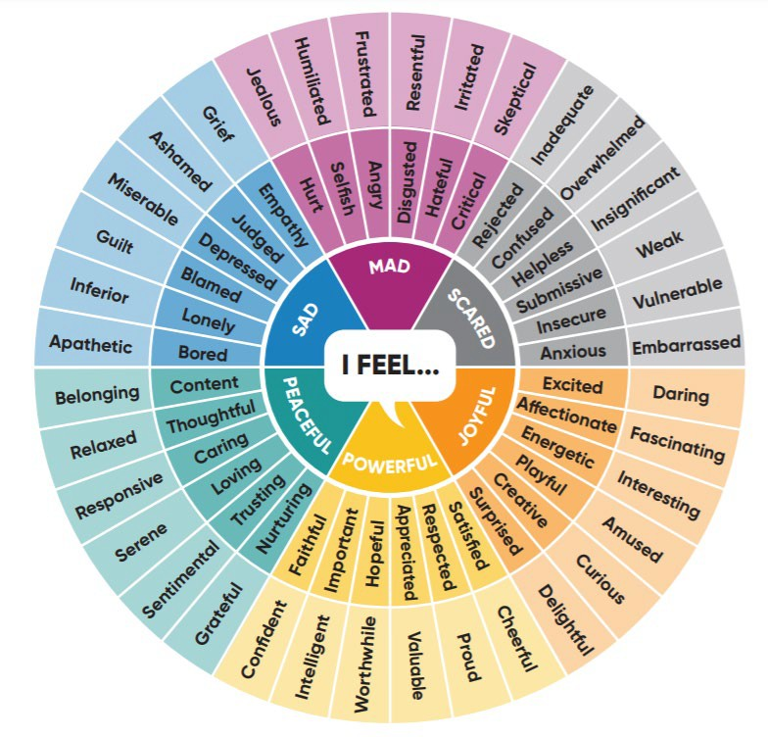

Full Feelings Wheel
(from Dr. Gloria Willcox)

Uncovering Equity Opportunities: Breakout Instructions

- Using the fill in the blank template below as a guide, individually brainstorm 1-2 equity opportunities in your setting that you want to focus on.

- As a group, share the statements you came up with and pick ONE population/service to focus on.

- As a group, ask “why” the equity opportunity is not currently happening. Continue to ask “why” and document your answers to uncover opportunities for improvement in your setting.

  - Note: Try to include only what you know to be true (avoid speculating). If you know there is a service gap but don’t know why, that’s ok! Name where you are unsure or where your own knowledge gaps exist.

Equity Opportunity Statement

There is an opportunity to ensure (subpopulation) equitably benefits from (aspect of program, resource, or service) by
(structural or systemic determinant to be addressed).

This doesn’t happen now because: .

Uncovering Equity Opportunities: Breakout Room Handout

Why?

Why?

Why?
Why?

Why?

Equity Opportunity:
_
This doesn’t happen now because:
_

Why?

Why?

Why?
Why?

