Key Driver Diagram - Facilitation Guide
Session Preparation
Prior to beginning this activity, populate your team’s Jamboard with:

- Your team’s draft Aim Statement. Type this into the ‘Aim Statement’ column (pink sticky note).
- The 1-2 variables the team identified as targets for action during the Causal Loop Diagram session. Type these into the ‘Key Factors’ column (green stickies).
Breakout Room Steps/Timing
- Review the team’s Aim (1 minute)
- Review the team’s Key Factors (1 minute)
- Brainstorm Sub Factors (5 minutes)
- Brainstorm Innovations to impact Sub Factors and Key Factors (18 minutes)
- Discuss Evidence and Equity Reflection Questions and Wrap-up (5 minutes)
Link to Jamboard Example and Template

The Jamboard for this activity consists of two frames. The first frame is an example of a completed Key Driver Diagram, and the second frame is a blank Key Driver Diagram.
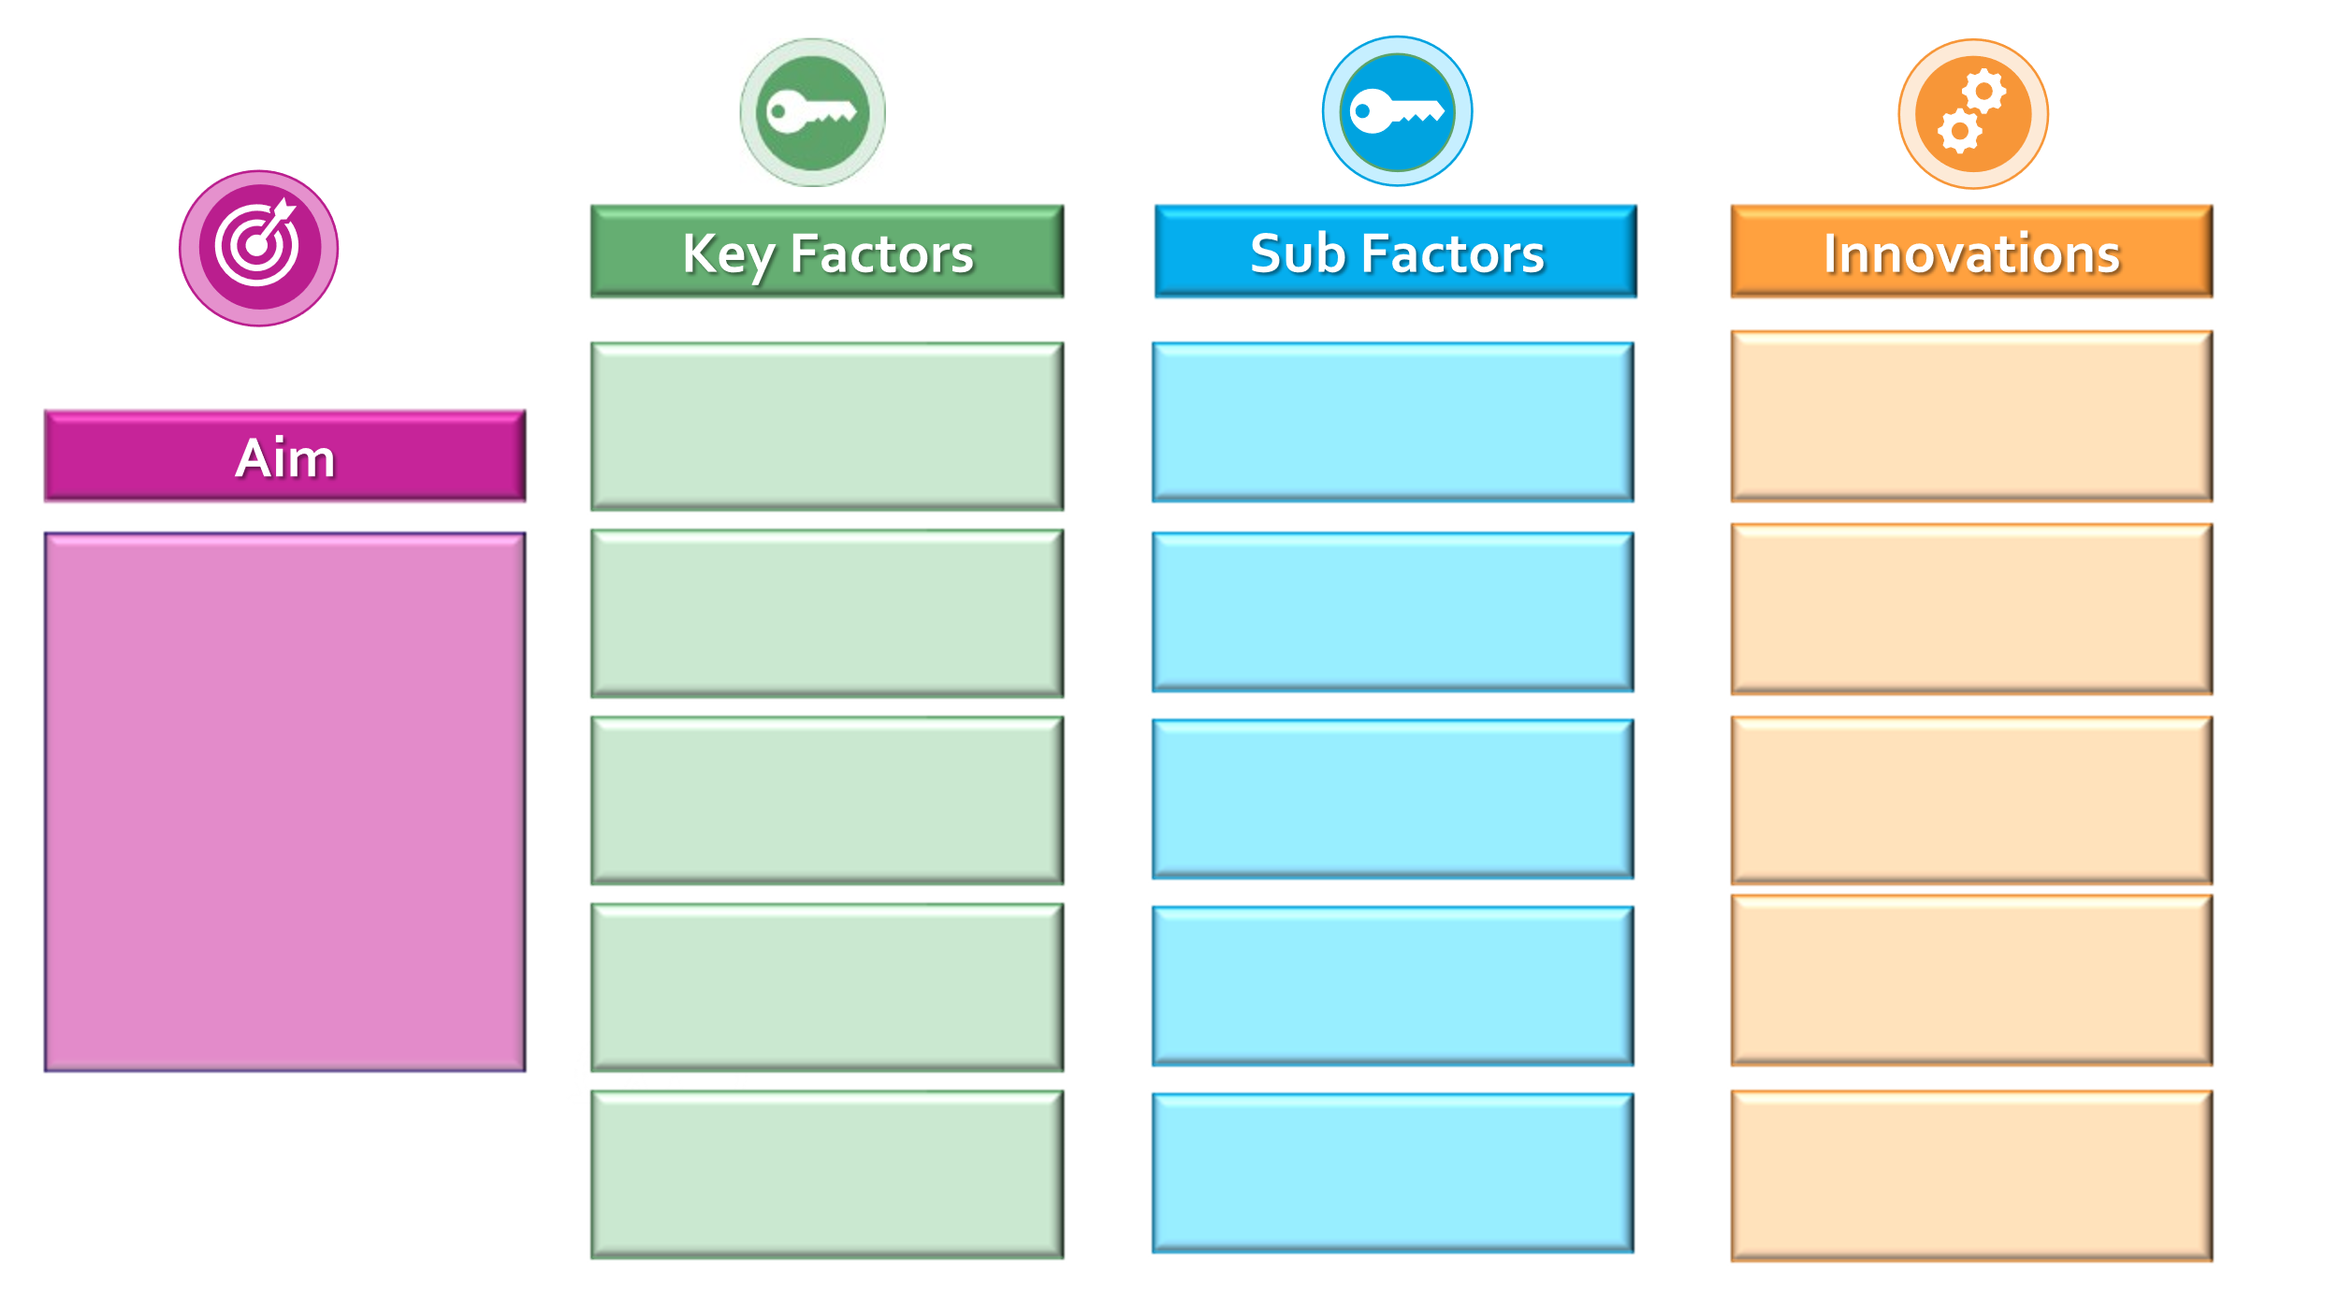

Note

- The aim of this exercise is to provide teams with the opportunity to work through the Key Driver Diagram with their own project so they can learn the process.
- It’s okay if your team only identified one variable (Key Factor) from their Causal Loop Diagram activity that they want to work with for the Key Driver Diagram exercise.
- If it seems like your team is stuck on a step, feel free to move them to the next step and remind them that they can always circle back to this tool later.

Activity | Timing | Notes
Share the Jamboard link | ________ | Once your team arrives in your breakout room, pull up the team’s Jamboard for this activity and share your screen. Be sure to provide your team with the link as well via the chat box and ask folks to open this on their computers so they can follow along with the activity.
Step 1: Set the Stage/Providing Context to the Activity | 1 minute | - Explain the importance of having diverse perspectives across their team, within their agency, with their partners, and especially those who are impacted by the programs they implement. Explain that this brainstorming activity will bring everyone’s perspective to the challenge they are trying to address and help them identify all the potential actions they might take.  - Read the team’s Aim statement out loud. Remind everyone it is okay if it is still a draft statement as the current aim is just for the purposes of learning to apply the Key Driver Diagram. The aim can always be refined later.
Step 2: Brainstorm Key Factors | 1 minute | - Explain that the second step in the process is to identify Key Factors--the things that must change in order to see an improvement in their aim statement.  - Remind the team that the 1-2 key factors listed on their Jamboard are the same 1-2 variables they identified as targets for action during the Causal Loop Diagram activity before the break.  Note: A copy of the team’s CLD can be found on the first frame in the Jamboard. Feel free to flip to this to orient the team if useful.
Step 3: Brainstorm Sub-Factors | 5 minutes | - Explain that the third step is to identify Sub-Factors which impact the Key Factors.  - Ask everyone to reflect on the following question: What specifically about {insert a Key Factor} must be changed in order to improve {insert Aim Statement}?  - Example question: What specifically about eligibility criteria must be changed in order to improve access for CYSHCN?  - Remind the team to look back at their Causal Loop Diagram and use variables from this.  - If the team doesn’t have variables from the Causal Loop Diagram that make sense as Sub Factors, give everyone a few minutes of silence to jot down ideas and then ask them to share verbally.  - Have an identified notetaker capture the ideas in the team’s Jamboard (one idea per sticky).  - Ask the notetaker (or other team members) to arrange the ideas so similar ideas are paired. The goal is to create themes/groupings of the ideas.  - Once all ideas have been captured, ask for additional ideas.  - Repeat this process for the team’s second Key Factor if they have one.  Note: If the team only has one Sub-Factor that they have identified, or you are approaching 10 minutes left for this section, move to Step 4.
Step 4: Brainstorm Innovations to Impact Sub Factors and Key Factors | 18 minutes | - Explain that the final step is to identify Innovations which will impact each Sub Factor.  - Select one Sub Factor from the list.  - Ask everyone to reflect on the following question: What changes/strategies might we test that will impact {insert selected Sub-factor)?  - Example question: What changes and strategies might we test that will impact the rules/policies surrounding patient qualification for services?  - Give everyone a few minutes to jot down their own ideas. Ask everyone to share their ideas. Have an identified notetaker capture the ideas in the team’s Jamboard (one idea per sticky).  - Once all ideas have been captured, ask for additional ideas.  - Repeat this process for each Sub Factor from Step 3.
Evidence and Equity Reflection Questions and Wrap-up | 5 minutes | By 4:45 pm, please make your way to this activity if your team is not already here. William will bring everyone back to the main room at 4:50 pm.  Guide your team through a discussion of the following questions and ask them to be prepared to chat/briefly discuss their responses or any aha moments when they come back to the main room.  - Reflect back on the Factors, Sub Factors, and Innovations you identified.  - What information is missing from your KDD? Why do you think these gaps exist? How might you collect the information you need?  - How is the perspective of those with lived experience reflected in your KDD? How do you know?  - How might you seek additional input from those with lived experience?  - What are some next steps for your team based on this tool? (e.g. share with additional stakeholders to gather their input, use the diagram at an upcoming meeting to help prioritize which innovations to work on, use the diagram to identify ways to measure progress and success, etc.)

Key Driver Diagram Tool

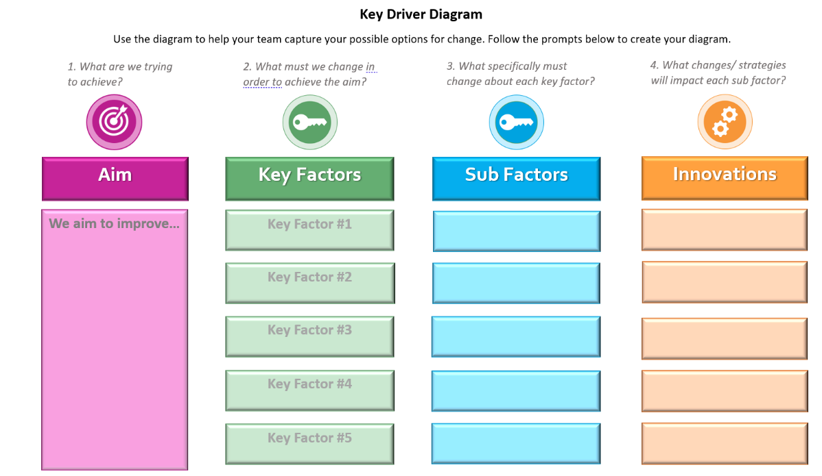

Click here to access a blank full-size version of this tool.

