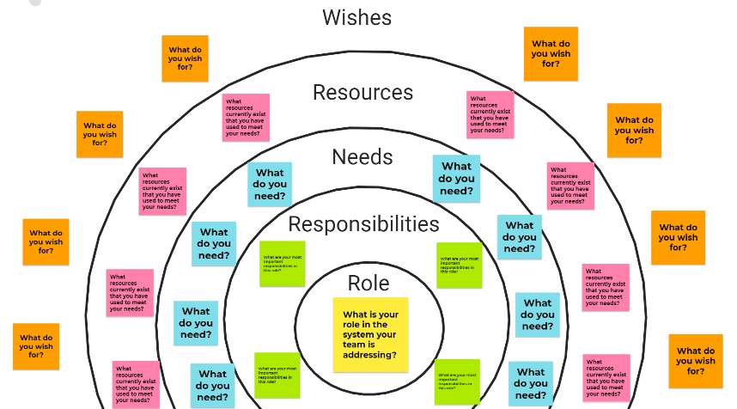
System Support Maps

System support maps are used to understand the role an individual plays in a system, their responsibilities or objectives/goals, needs for meeting each, resources used to support needs (and notes on whether these resources are helpful why/why not), and wishes for being better supported or better supporting the system.

Please put your name on your map.

ROLE
As you map your system supports, what is your role/identity?
- What is your role on the health transformation challenge team? Write this on one YELLOW sticky.
- Share any context/detail that helps ground your map on a second sticky behind your role.

RESPONSIBILITIES
What are your most important responsibilities in this role?
- What do you see as the main activities you are responsible for as part of this team’s work?
- Identify the most important 3-5 responsibilities you will be carrying out over time. Write each responsibility on a GREEN sticky.
- Draw an arrow from your role to each responsibility it creates for you.

NEED
What do you need?
- For each responsibility, what do you most need to succeed (in general terms – time, patience, knowledge, access to information about X, etc.)? Write each need on a BLUE sticky.
- Draw an arrow that links each responsibility to the needs it generates (it’s ok to draw multiple arrows if needs repeat).

RESOURCES
What resources currently exist that you have used to meet your needs?
- For each need, what specific resources have you tried in the past (our team’s application, other similar work, a website, a colleague, etc.)? Write each resource on a PINK sticky.
- Draw an arrow from each resource to the corresponding need it targets.

WISH
What do you wish for?
- … to improve any resource you use or address any unmet need? (Not goals or outcomes)
- Write each wish on an ORANGE sticky.
- If the wish targets something on a map, draw an arrow to make that visual connection.

