Accelerating Equity learning community (AELC) workbook

This AELC Workbook can be used to document ideas, discussions, and next steps from teams’ work during the May 2022 AELC Skills Institute. The activities should be developed collaboratively with all team members and revised as needed over time.

Throughout the learning process, your change/challenge may evolve. Strategies for achieving it will therefore also evolve. This document is intended to assist teams in tracking their progress as they address a challenge through the equity ecosystem framework depicted on item 2 of the Table of Contents.

Table of Contents
- Team Roster and Challenge/Change Statement
- Team Agreements
- Organizational Equity Ecosystem
- Equity Lines of Inquiry
- Empathy Profile Worksheet
- Network Cultivation Map
- Logistics
- 30/30

- TEAM ROSTER

- Who is on the team?
- What are their roles and responsibilities?
- What perspectives do they bring to the team?
- Are there specific communities or populations that they have connections to?

Current  Team Members | Role, Responsibility, Perspectives and Connections
Additional needed members | Role, Responsibility, Perspectives and Connections

CHALLENGE/CHANGE STATEMENT:

Version 1, Date:

Version 2, Date:

Version 3, Date:

Version 4, Date:

Version 5, Date:

- TEAM AGREEMENTS
As a team, consider how you want to be together. What are the rules or guidelines that govern your behavior as a team? How will you hold yourselves accountable to those guidelines?

Team Agreement Template
Instructions: Record the agreed-upon behavior. | Instructions: Record the indicator that demonstrates the behavior.
Example: We will honor each other’s perspectives. | Example: By asking curious questions and sharing time equitably.
Example: We will have fun. | Example: By making time for humor and laughter in our meetings.

- ORGANIZATIONAL EQUITY ECOSYSTEM
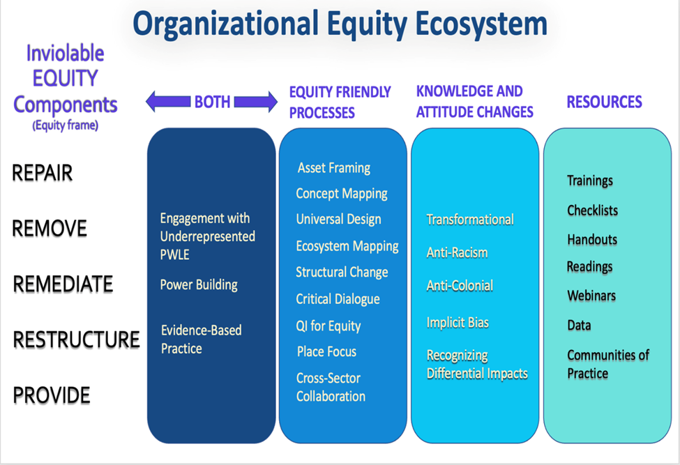

It’s not about what you do, it’s about what you build.

All of the elements depicted in the Organizational Equity Ecosystem work together.

The organizational equity ecosystem depicts the inviolable equity components (equity frame) beside the equity friendly processes that are necessary to enable progress.

These processes essentially serve to get us “off the hamster wheel” or out of the rut of the current status quo. They are tools for redesigning the work we do. They get at The How.

Knowledge and attitude changes are critical for comprehending why each of the components in the ecosystem are important. Knowledge and attitudes are critical for achieving a mental shift from transactional to transformational.

The listed resources are some examples of tools to help navigate this complexity. Note: Being trained is necessary but not sufficient to promote equity. The training must result in changed action. Being trained without action or being trained without a transformational mindset will only result in maintaining the status quo.
- EQUITY LINES OF INQUIRY

Instructions
Rethink your equity challenge through an equity lens. Have discussions with your team members about the following questions. For questions your team cannot answer, seek counsel from coaches, WDC staff and others. For questions they cannot answer, identify what PWLE or others you may need to consult.

- How would you articulate the challenge you came to address in an elevator speech?

- Who are all of the populations most likely to be adversely affected by your challenge, and are currently under-represented in your decision-making tables? Keep a list of these populations on your wall to remind you to keep learning more about their specific life contexts and experiences relating to your challenge.

- How and why are under-represented groups you identified differentially impacted? How are “isms” holding the problem in place? (Racism, class, gender inequities, sexual orientation, etc...) How will you address these?

- What past history is playing into the current situation, and in your relationship to the PWLE most affected? How will you address this?

- What is the band-aid solution—the thing you are most inclined to do first to fix the problem in the present (“stem the bleeding”)

- What longer term changes will be necessary to prevent new people from being adversely affected by this challenge, and how will you sustain and accelerate improvements? (for example, how will you transform power, relationships, structures, resource flows, interpersonal behaviors, policies, procedures, mental models…)

- How will you adapt your design or process to meet the needs of people who may represent multiple or diverse identities, experiences and needs?

Operationalizing R4P: EQUITY LINES OF INQUIRY

Ensure that the discussions leading to decisions explicitly focus on understanding and addressing the underlying factors specific to creation of inequities. This requires developing lines of inquiry that assess at least five main categories of factors that contribute to inequities.

REMOVE REPAIR RESTRUCTURE REMEDIATE PROVIDE

REMOVE —Where is racism, implicit bias, differential treatment, differential access, differential outcome or collateral impacts occurring in various population groups?

(Explicitly address racism and other “isms”, differential impacts or collateral impacts on populations that may exist and defines strategies to address) What needs to be done to create a process that does not result in differential impacts?

REPAIR— What past exposures produced damage that impacts the current challenge, (e.g. affect current ability (of population) to access health care, maintain health, or practice healthy behaviors?

Have we actively recognized, discussed and addressed historical disadvantages of populations we serve?

Have we Improved participation by improving quality of service delivery, by increasing outreach and by repairing damaged reputation in community from prior history of poor treatment?

(Explicitly addresses historical origins of oppression and relation to current health outcomes and defines strategies to repair damage/reduce harm)

RESTRUCTURE -- What processes/social forces continue to produce risk, disadvantage and other adverse effects in vulnerable populations?

In what ways do our current processes:

- ___Pass over a group defined by (race, class gender, history) because it is just too hard to include them given limited job resources

- ___Omit, forget, exclude, triage, don’t invite or restrict involvement of African American or Native American people, which keeps them from participating on an equal footing

- ___Allow one population group to be left in undesirable circumstances while enabling support for another group

- ___Disproportionately (albeit unintentionally) put obstacles in the path of some groups defined by (race, class gender, history) resulting in their disadvantage

- ___Impose punishment, limitations or mistreatment that disproportionately affect certain groups because of (race, class gender, history)

How do we develop a new process that addresses this disadvantage?

(Strategies/actions that will institutionalize transformed processes …
and stop production of new risk)

REMEDIATE -- How can we buffer people from adverse effects while we wait for structural change?

In what ways does our program/institution:

- Neglect to help people in the face of need
- Avoid people or places because there is a perception those people/places are too different or dangerous to risk interacting with or the problems too deep to address
- Fail to provide timely to accurate information, training, resources, or education to a population group that has a need, because we do not know how to address their specific needs
- Neglect or marginalize people because they are unable to participate in ways deemed acceptable
- Provide alternative strategies for people who do not have access to standard resources
- Consider the possible negative consequences of temporary buffers/solutions

(Addresses risks/challenges/exposures experienced in real time)

PROVIDE -How can we ensure that peoples’ ability to access, participate in or benefit from services and care are not limited by social, political, cultural, economic, physical ability and other identifiable characteristics?

(Designs intervention, policy, procedures, programs that consider (intersectional) needs of the most- in- need populations (e.g. those experiencing health inequities)

- EMPATHY PROFILE WORKSHEET

Category | A person | An OrgANIZATION
- Profile Name:
- Demographics:
- Context (current story):
- Things they see:
- Things we've heard them say:
- Things they do, behaviors we've observed:
- Things they hear from others:
- What decisions are they making?

JOBS TO BE DONE
- What are their “jobs to be done”?

GAINS
- What are they seeking?
What opportunities do they see?
- What are their aspirations?
- What do they wish for?
- What do they need?

PAINS
- What are their fears, anxieties? Frustrations, barriers?
- Other thoughts/feelings that motivate them?

How we will validate our guesses:

NETWORK CULTIVATION MAP

Identify one health equity opportunity

Who has lived experience related to this opportunity?

Why (or why wouldn’t) they want to partner with us?
(Think about history, aligning or conflicting interests, capacity, etc.)

What actions do we need to take in order to cultivate relationships with each individual/community?

Who on our team should cultivate relationships with each individual/community?

Developed by the National MCH Workforce Development Center

- Logistics

SPACE FOR PLANNING HOW TEAM WILL REMAIN IN COMMUNICATION AND WORK TOGETHER, INCLUDING COACHES

- When and where do we meet?
- Who needs to be there?
- How do we share documents?
- How do we communicate in between meetings?
- What else needs to be decided about how we complete the work?

Logistics | Decisions | Notes
Meetings

Documents

Communication

Resources

7. 30/30 Action Plan+ Review Discussion

Date |  | State |  | Aim

30-Day ACTION PLAN
Work/Activity | Product | Indicator/Measure | Person | Deadline

30-Day REVIEW DISCUSSION
- What have we accomplished? Reflect on the action items from last meeting, above.
- What have we learned over the last 30 days? For instance: new information, observations, insights, struggles, results of data analysis)
- Does our proposed course still make sense? Based on the learning to date, do we need to adjust?
- When, where, and how will we get together next (in about 30 days)?
Date: | Time: | Place:
- PROGRESS / DIRECTION METER
We’re working our plan. Making steady progress. | We’ve hit some road bumps. Making adjustments. Goals/outcomes and project are still the same. | We’re stopped. Making major changes to our project and/or outcomes.
- What (if anything) should we be communicating? To whom? Using what format? By when?

NEW 30-Day Action Plan
Work/Activity | Product | Indicator/Measure | Person | Deadline

N O T E S:

